# IBM CLOUD VISUAL REGONITION

# GOOGLE CLOUD VISION TOOL

The Google Cloud Vision API is a service that allows you to analyze the content of images using machine learning and computer vision techniques. Here’s an overview of how it works:

**STEP 1**: Image Input

The process begins by providing an image as input to the Vision API. You can use various image formats, including JPEG, PNG, and GIF.

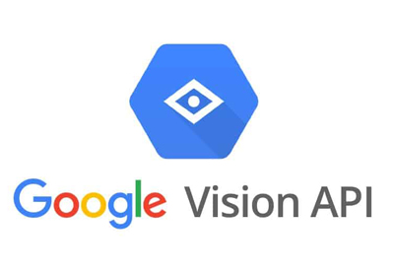

**STEP 2**: Request to the API

You send a request to the Vision API using the client library or directly via HTTP. This request includes the image to be analyzed and specifies the types of analysis you want to perform on the image.

**STEP 3:** Image Preprocessing

The Vision API performs some preprocessing on the image, which can include resizing and normalization. This step ensures that the image is in a suitable format for analysis.

**STEP 4**:Feature Extraction

The Vision API uses deep learning models and computer vision algorithms to extract various features and information from the image. These features may include:

**STEP 5**: Label Detection

Identifying objects and scenes within the image.

**STEP 6**: Text Detection

Recognizing and extracting text from the image.

**STEP 7**:Face Detection

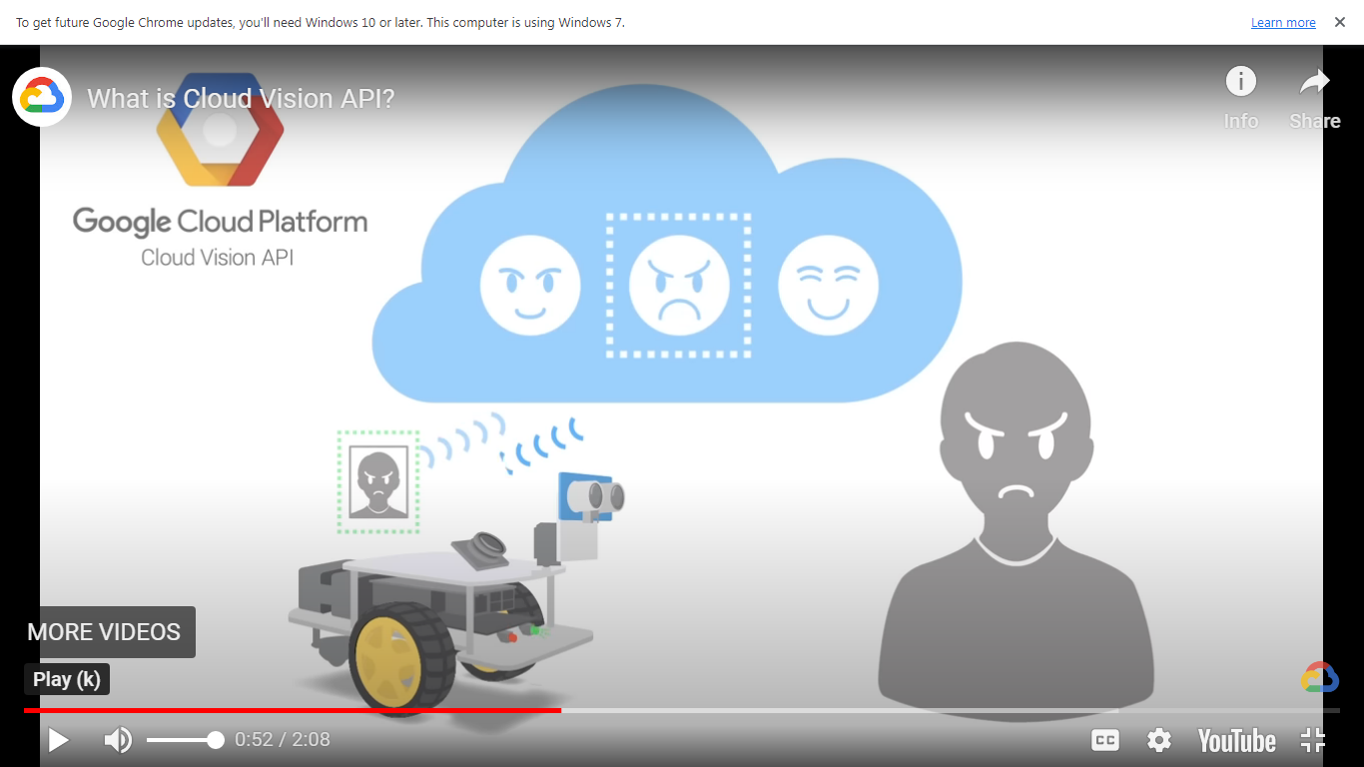

Detecting faces, landmarks, and emotions.

**STEP 8**:Logo Detection

Identifying logos within the image.

**STEP 9**:Landmark Detection

Recognizing famous landmarks.

**STEP 10**:Safe Search Detection

Determining if the image contains adult content, violence, etc. Analysis and Annotation:

The Vision API analyzes the image based on the requested features and annotates it with the results. For example, it may provide a list of labels describing the objects in the image or recognize and extract text.

**STEP 11**:Response

The API sends back a response that contains the analysis results in a structured format, typically in JSON. You can then access this data to use in your applications.

**STEP 12**: Interpretation and Action

You can interpret the results to make decisions or take actions based on the image’s content. For example, you could automatically tag images, filter content, or extract information from documents.

**STEP 13**:Post-processing and Integration

You can further process the results as needed and integrate them into your applications, websites, or other systems

**STEP 14:**Monitoring and Management

It’s important to monitor your API usage, manage your API keys and authentication, and keep an eye on any associated costs through the Google Cloud Console.

The Google Cloud Vision API leverages Google’s vast machine learning infrastructure and constantly updated models to provide accurate and reliable image analysis. It can be used in various applications, such as content moderation, image recognition, document analysis, and more.